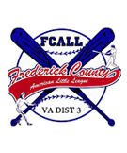
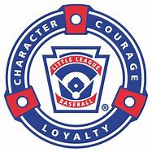
BAT-A-THON
Saturday, May 18th, 2019

FUNDRAISER TO BENEFIT FREDERICK COUNTY AMERICAN LITTLE LEAGUE
Frederick County American Little League will be holding our annual fundraiser on Saturday, May 18th, 2019. This year, we will be having our second spring bat-a-thon. We are aiming to raise $10,000. These funds will go towards buying new equipment and maintaining/renovating school fields.

WHAT IS A BAT-A-THON?
A Bat-a-thon is an exciting competitive fundraiser; where players will collect donations from friends, family, neighbors, and local businesses. The field will be segmented into zones, each player will receive ten pitches, and each hit will be scored based on the zone the ball lands. Each players score will be calculated, and champions will be awarded. Prizes will be awarded to the top scoring team, in addition to, individual champions for each division. The top three donation collectors will also be awarded; see below for prize details.
Top Scoring TEAM per division will receive a prize from Texas Roadhouse.
Top scoring INDIVIDUAL per division will receive a prize.
Top donation collection TEAM wins an ice cream party.
Top INDIVIDUAL collectors:
1st place = $250 gift card
2nd place = $200 gift card
3rd place = $150 gift card
(To be eligible for a prize, you must collect a minimum of $20.)
Thank you for your participation. We look forward to seeing everyone come out and support the kids of FCALL in this exciting home run derby type atmosphere.
Turn in the Donation Log and donations to the team manager or team parent on Saturday, May 18th, 2019.

